Brian, thanks for this suggestion. Here is the workflow that we are putting into place compared to what we are removing. This started with Jimmy and Dan about a year ago. However, when Jimmy left this never got picked up since Dan pretty much took over Seradex administration. Last month I was assigned the task of completing the project.

We have labels that are being produced for Carton, Core and Stock using a program called LabelStation which has a database on the Seradex server. When a WO or SO is entered into the search field for the program, the labels are generated using Bartender templates that are designed to pull from various fields in the Seradex database with the referred to values listed on the label.
Part of this is the ability to add a logo to one of the label types based on what is entered in the field referred to in the SQL view Jimmy created. Jimmy created the views Bartender WO and Bartender SO and configured it to look for a location in the LabelStation database not the user defined field in the Seradex database. As configured, we are unable to manage the logo insertion into the label generated. We want to use the Carton Label form field in the User Defined tab of the CRM for the CSR to enter the filename of the logo image. Then that logo will be placed in the appropriate directory.
As setup, the person generating the label will enter/scan the WO or SO barcode into the top form field as pictured. When the WO or SO is found, based on the query built into the Bartender label template, the preview is generated as well as the data auto filled into the form fields below the QTY field. 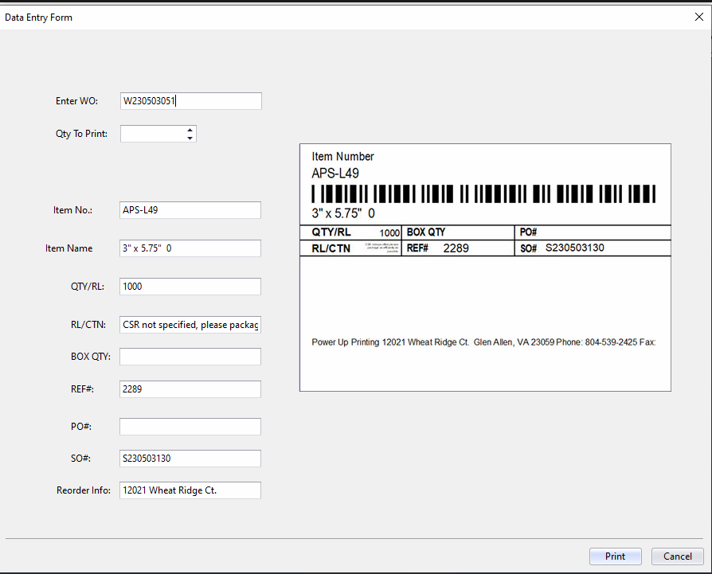
Here is the label designed by Jimmy, edited from the Bartender file used in LabelStation now.
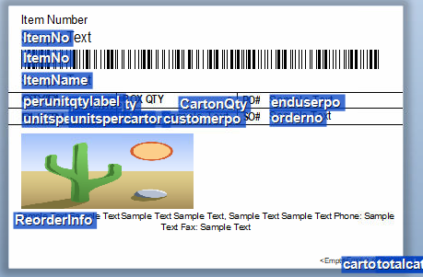
The image is where the logo would be inserted. Below is the current configuration for how the label is located.
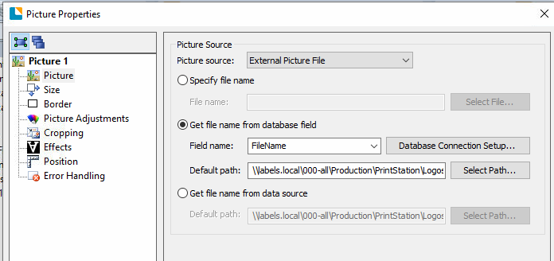
FileName detail in Bartender
FileName detail in SQL
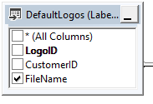

By user the user defined entry that would contain the filename the logo should add itself to the label preview and printout.
There are plans to incorporate RFID into this later this year which is likely why use of Telerik was not chosen.

I hope this explains things satisfactorily.

Friday I will be WFH to review Bartender and SQL training material to work on this project without distraction. If after reading this, you would like to schedule a discussion for Friday I can set aside time for that.

Thanks

